Project Design Phase-II
Data Flow Diagram & User Stories
Date | 04 February 2026
Team ID | LTVIP2026TMIDS66306
Project Name | Gemini historical artifact description
Maximum Marks | 4 marks

Data Flow Diagrams:
The Gemini Historical Artifact Analysis System is designed to collect, store, process, and analyze historical artifacts from the Gemini space missions. The system begins with artifact data sources, which include important information such as artifact name, mission name, astronaut, mission date, artifact type, artifact condition, and storage location. This data is stored in the Historical Artifact Archive, which serves as the central repository for all artifact records and preservation information.
Flow Diagram:
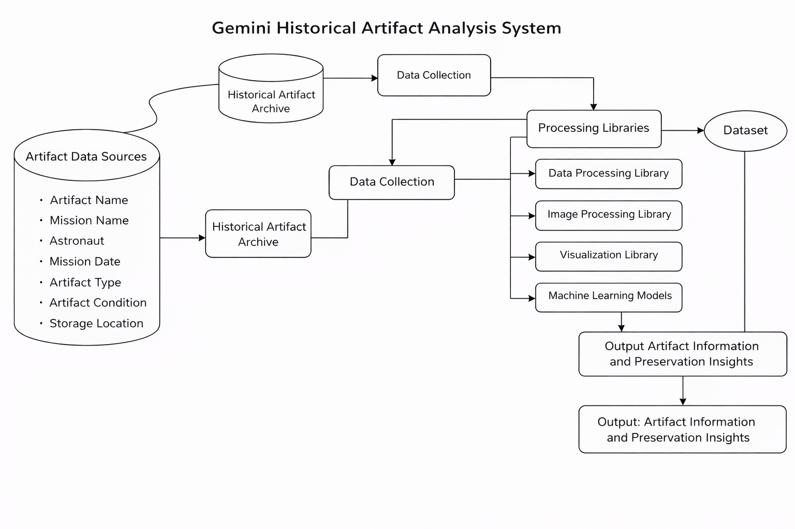
User Stories
Use the below template to list all the user stories for the product.
User Type | Functional Requirement (Epic) | User Story Number | User Story / Task | Acceptance Criteria | Priority | Release
Archivist | Artifact Data Management | USN-1 | As an Archivist, I want to upload and store Gemini historical artifact information so that it can be preserved digitally. | System allows artifact upload with name, mission, description, and images. Data is stored securely. Upload completes successfully without errors. | High | Sprint-1
Researcher | Artifact Search and Access | USN-2 | As a Researcher, I want to search and view Gemini historical artifacts so that I can use them for research and study. | System provides accurate artifact search results. Artifact details and images are displayed clearly. Search results load within 3 seconds. | High | Sprint-1
Student / Public User | Artifact Viewing | USN-3 | As a Student, I want to view artifact information so that I can learn about Gemini space missions. | Artifact information is displayed clearly. Images and mission details are accessible. System provides easy navigation. | Medium | Sprint-2
System Administrator | Artifact Database Management | USN-4 | As an Administrator, I want to manage artifact records so that the system remains accurate and secure. | Admin can add, edit, and delete artifact records. System maintains data integrity. Unauthorized access is restricted. | High | Sprint-1
Museum Curator | Artifact Documentation | USN-5 | As a Curator, I want to document artifact present | System allows preservation status updates. | High | Sprint-2

